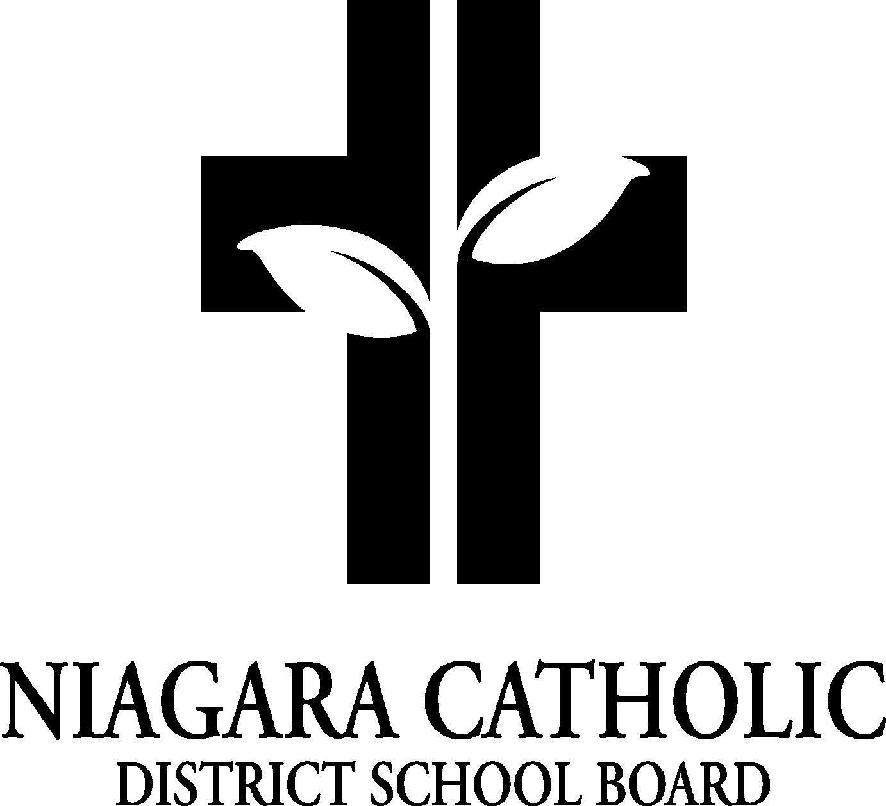
St. Patrick Catholic School Council Minutes November 6, 2023

A. ROUTINE MATTERS:.

- Opening Prayer – MK Welcome and prayer
Lord, we come before you this evening and we ask your divine help. We are here tonight to talk about ideas and decisions that impact the lives of the children we serve. Let us always keep their needs in the centre of our thinking.
- Presentation – Fundraising presentations
3. Roll Call

Members | Affiliations | Present | Excused | Absent
Mrs. Maltman | Chair – | a
Mrs. Maloney | Co-Chair – | a
 | Secretary/Treasurer-Principal
 | Recording Secretary – Principal
 | Teacher Representative – NONE |  |  | a
 | Non-Teaching Representative – Ralph Caperchione | a
 | Parish Representative – Father Wes
Parent Representatives and email address
Mrs. Stivoric | j.k.stivoric@gmail.com | a
Mrs. Anna Simpson | kfn22@yahoo.ca |  |  | a
Mrs. Maltman | leeannmaltman@gmail.com | a
Mrs. Eckert | jessicarmt4@gmail.com |  |  | a
Mrs. Herbert | herbertclmw@gmail.com |  |  | a
Mrs. Honsberger | meaghanbodis@gmail.com
Mrs. Tyminski | leeg17@hotmail.com | A

5. Approval of the Agenda

Moved by the committee
THAT the St. Patrick Catholic School Council approve the Agenda of the St. Patrick Catholic School Council Meeting on Monday November 6, 2023
CARRIED

6. Disclosure of Interest - NONE


AGENDA & Minutes

7. PRESENTATIONS- None

8. PRINCIPAL’S REPORT
- Big Box fundraiser – we sold 181 boxes. We made $1991.00.
- The calendar with gift cards. We raised $4200.00 for selling 420 calendars
- Midterm interviews Thursday November 23. 3:30 to 6:00
- Christmas Concert – Wednesday December 13. Performance in the morning and afternoon.

9. NEW BUSINESS/QUESTION – Pepperoni on Pizza. In the new year we will try it on the pizza.
CSC would like to try a new spirit wear supplier - Maddalena. We will look at this in the New School Year.

10. NEXT MEETING: January 2024

11. ADJOURNMENT Mary Kay Kalagian

This meeting was adjourned at 7:10 pm
12. CLOSING PRAYER: Mary Kay Kalagian
Almighty God, we started this meeting with you, and we are closing it with you. Thank you for everyone in attendance for their support, collaboration and respect. Please guide everyone safely home. We ask this through Christ our Lord. Amen

